December 8, 2023
Stanton Community School

.
Get Your Stanton Bracelets!!
Stanton dance team is selling purple/white/black Puravida bracelets to raise money for nationals in February. $10 each Stanton colors! These would make excellent Christmas gifts! Please contact Jana McCunn or any dance team member to purchase!
Red Cross Blood Drive
Stanton's FCCLA is sponsoring a Red Cross Blood Drive on Wednesday, December 13 from 9:30 AM- 3:30 PM at the Viking Center. Your donation not only saves lives, but it also helps Stanton seniors with scholarship money. To schedule an appointment, call the high school office or go to redcrossblood.org.
Pink Out Sponsored by the FCCLA
Stanton's FCCLA is sponsoring a "Pink Out" night on Friday, December 15. All the money that is raised is donated to Coaches vs Cancer to fight cancer. There will be a variety of activities that evening to raise money.
Driver’s Education
We will be offering a Driver's Ed Course, starting January 8 - Feb 7. Cost of the course is set at $325.00 for Stanton students. We have a signup sheet in the office, if your student will be 14 years or older and will have their permit in hand by the 1st day of class, please have them stop in and sign up. We do need a copy of their permit in the office before class starts. If you have any questions, please call the HS office 829-2162.
There will be more information to follow!
Driver’s Ed Schedule for 2024
Monday, January 8 6:30AM-8:00AM
Wednesday, January 10 1:30PM- 4:30PM
Friday, January 12 6:30AM-8:00AM
Monday, January 15 (No School) 8:00AM-11:00AM
Wednesday, January 17 1:30PM- 4:30PM
Friday, January 19 6:30AM-8:00AM
Monday, January 22 6:30AM-8:00AM
Wednesday, January 24 1:30PM- 4:30PM
Friday, January 26 6:30AM-8:00AM
Monday, January 29 6:30AM-8:00AM
Wednesday, January 31 1:30PM- 4:30PM
Friday, February 2 6:30AM-8:00AM
Monday, February 5 6:30AM-8:00AM
Wednesday, February 7 1:30PM- 4:30PM
Friday, January 26 6:30AM-8:00AM
Monday, January 29 6:30AM-8:00AM
Wednesday, January 31 1:30PM- 4:30PM
Friday, February 2 6:30AM-8:00AM
Monday, February 5 6:30AM-8:00AM
Wednesday, February 7 1:30PM- 4:30PM
Drive times will be set up with the students.

School Activities
Santa Lucia Festival of Lights is this Saturday at 7pm! Come and see the Elementary 1st - 6th Grade sing festive music along with the 5-6th Graders who will start the program with traditional Swedish Dancing. The theme this year is Santa Lucia Night! Funny skits will happen throughout the program along with Skona Maj Singers, Ceremony Singers and the Lucia Bride pageant as the town will vote on the next Santa Lucia Queen. The program starts at 7pm in the H.S. Gymnasium.
Winter Concert - Next Thursday, December 14th, is the winter concert featuring the 5th, 6th, and combined JH and HS band along with the JH and HS choirs. Alumni will be invited to sing along on The Benediction Song during the concert. The concert is a free-will donation and starts at 7pm in the H.S. Gymnasium.
Kindergarten Christmas Program
The kindergarten classes will have a Christmas program at 2:30 pm on Friday, December 15, in the music room (aka band room). Light refreshments will be served afterwards. Parents and grandparents are invited to attend.
Fifth Grade Food Drive
The 5th graders would like to have a Holiday Food Drive to help area families. We want to have a contest for all K-5 classes, to see who can collect the most points from now until Dec. 21st.
We will no longer have a points system for the items brought in. Instead, each item is just worth one point. The students that choose the winning team with the most points earn a movie and pizza party in January!
Please, when donating items, make sure they are not outdated! We look forward to helping the people in our community and having a fun contest while doing it. Thank you to everyone in advance for the generous donations and support!
Coach Ryan Sloth
Coach Sloth, author of children's books, will visit our school this upcoming week on Monday, December 11th to talk to our K-5 students. This is free to our school...so please show Coach Sloth a big thanks by ordering one or more of his books. Coach Sloth will share life experiences, discuss how he developed his characters, and deliver an anti-bullying message. More information will be sent home with students, and it will also be posted on the Stanton Schools Facebook page.

HEY SENIORS!
The yearbook is still looking for senior photos and baby photos of each senior.
We want to see the senior POV on portraits!
We have made some changes in the yearbook and want to showcase each senior, but we can only do that if you get those photos to us ASAP!
Help us dry Mrs. Charm's tears!
She's crying all day long!
Send your photos through email to her,
And turn her sobs into a song!

From the Desk of Our Principal
Upcoming Dates:
Friday, December 22nd - End of 2nd Quarter/1st Semester
Friday, December 22nd - 1:05/1:15 pm early dismissal
Thursday, January 4th - Classes Resume

Athletics
Viqueen Basketball
It would take the 1st quarter at Sidney before the Viqueens would hit their stride when dealing with the Cowgirls. A slow start and 10-9 first quarter lead was not an ideal situation to be in on the road at a perennial Corner Conference powerhouse. The Queens stepped it up in the 2nd frame and it started with defense, using full court pressure Stanton forced numerous turnovers which led to easy layups and a 30-point quarter pushing the halftime lead to 40-16. In the 2nd half the Cowgirls were unable to mount any kind of comeback as the Queens cruised to victory. Team Leaders: Leah Sandin 27 pts, 10 steals, 5 assists, 4 rebounds, Lauren Johnson 11 pts, 16 rebounds, 4 steals, 3 assists and Hannah Olson 17 pts, 6 rebounds, 6 steals, 3 assists. Stanton 62 – Sidney 35. The Viqueen’s relentless defense would pick up where it left off in Sidney as the defensive effort continued to produce easy offensive opportunities during the first half of play. The Queen’s would cruise to a dominating 50-15 halftime lead. Many facets of the game showed improvement from the first game of the season with the Queen’s shooting 43% from the field while holding the Tigers to 18% shooting, dominating the boards by out rebounding Griswold 49-23, collecting 20 steals, and playing team basketball by dishing out 22 assists. Stanton 66 – Griswold 25. Team Leaders: Leah Sandin 16 pts, 6 rebounds, 4 assists 6 steals, Lauren Johnson 15 pts, 14 rebounds, 3 assists, 2 steals, Kiela Franzen 8 pts, Hannah Olson 13 pts, 11 rebounds, Riley Burke 10 pts, 4 rebounds, Kyla Hart 10 assists.
Spotlight on Students of the Week 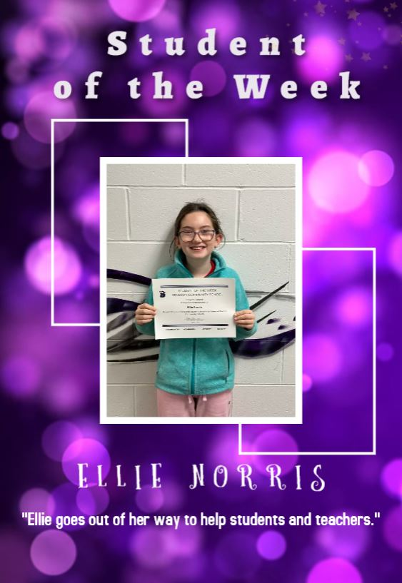 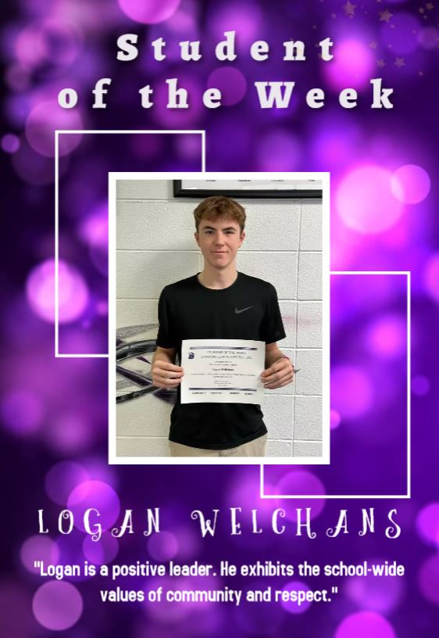

Upcoming Events
Fri., Dec 8th 4:00 JH G BB at EM (Old N. Valley school)
4:00 JH B BB w EM at VC gym
4:00 JV B BB at East Mills
6:00 V G BB at East Mills
7:30 V B BB at East Mills
Sat., Dec 9th 7:00 Santa Lucia in HS gym
Tues., Dec 12th 4:00 JH G BB w Essex
5:00 JH B BB w Essex
6:00 V G BB w Essex
7:30 V B BB w Essex
Wed., Dec 13th 1:05/1:15 Early Dismissal
Thur., Dec 14th 7:00 Christmas Concert in gym
Fri., Dec 15th 4:00 JH B BB w Fremont Mills
5:00 JV B BB w Fremont Mills
6:00 V G BB w Fremont Mills
7:30 V B BB w Fremont Mills

Lunch and Breakfast Menu
Mon., Dec. 11th Breakfast: Pop Tart/Muffin/Juice/Milk
Lunch: Hamburger/Bun, Potato Smiles, Baked Beans, Mixed Fruit, Cherry Crisp & Milk
Tues, Dec 12th Breakfast: Waffle/Muffin/Juice/Milk
Lunch: Chicken Strips, Mashed Potatoes/Gravy, Cooked Carrots, Oranges, Pineapple & Milk
Wed., Dec. 13th Breakfast: Breakfast Bagel/Muffin/Juice/Milk
Lunch: Burrito/Hot Dog, Corn, Ranchero Beans, Peaches, Ice Cream & Milk
Thurs, Dec 14th Breakfast; Dutch Waffle/Muffin/Juice/Milk
Lunch: Salisbury Steak, Cheesy Mashed Potatoes, Green Beans, Mixed Fruit, Mandarin Oranges, Roll & Milk
Fri., Dec 15th Breakfast: Cinni Mini/Muffin/Juice/Milk
Lunch: Pizza Crunchers, Lettuce, Carrots, Applesauce, Pears & Milk

Staff Highlights
Melissa Yeager, Paraeducator
Mrs. Yeager is originally from Red Oak and she graduated from Red Oak High School. She and her husband Chet have three children, Chelsey, Amanda, and Max. They also have two grandkids, Crew and Cal.
Mrs. Yeager enjoys gardening and houseplants, cooking, reading, and playing with her grandkids. One of her favorite things about working at Stanton is that she loves helping the students find books they enjoy to read in the library. She also loves helping the students read and do math. Her favorite thing is that no two days are the same.
Mrs. Druivenga - Elementary Secretary, Coach
Mrs. Druivenga grew up in the small rural community of Guss, Iowa on a dairy farm where her dad continues to live today. She is a graduate of Villisca Community School and attended Northwest Missouri State University. She then graduated from Buena Vista University with a bachelor’s degree in business.
Mrs. Druivenga and her family moved to the Stanton area in March of 1996, and she began her duties as the Elementary Secretary in September of 1996. Mrs. Druivenga and her husband Sean have three children – Dilan, Dakkota and Devin – who are all graduates of Stanton. Her two grandchildren, Noah who is 3 and Jonah who is 1, are the apple of her eye and live in Kansas City.
Through the years, Mrs. Druivenga has filled many different roles and a variety of extra duties including junior class sponsor, senior class sponsor and TeamMates coordinator. She is currently the head volleyball coach and junior high volleyball coach as well as the junior high track coach at Stanton.
In her free time, she enjoys spending time outside and working in the yard, taking walks with Daxx (her very spoiled Chihuahua) reading, crafting, watching volleyball, weekend trips to Kansas City to see the grandkiddos and taking rides on the Harley with Sean.
Mrs. Druivenga’s favorite thing about working at Stanton Schools is the wonderful students that she has been blessed to watch grow through the years and the outstanding staff members and administration that she has so enjoyed working with. She believes that the students have been the best teachers she has ever had as she continues to learn so much from them every day. Mrs. Druivenga has truly enjoyed being a small part of such a wonderful school and an outstanding community!

Santa Lucia Bake Sale
The Santa Lucia Bake Sale Committee would greatly appreciate community members to donate baked goods to the bake sale. Please bring items to the school concourse on Saturday, December 9th, before 6.

Community Events
Drive Thru Christmas
On Saturday, December 9th (after Santa Lucia), come check out the Christmas trees, lights and more at the OLY in Stanton! Donations to the local food pantry are requested but not required to drive through.
Stanton’s Legion Santa Claus
Stanton children up to and including second grades are invited to walk through and see Santa Claus at the Stanton Old Lumber Yard Event Center on Saturday, December 16th from 5pm-7pm. Anyone is welcome to walk through and see Santa, but only those who call Santa’s helpers will receive gifts. The high school choir will provide music. Hot chocolate and apple cider will be served. Santa’s helpers will be waiting to talk on the phone (712)829-2687 to the children on Wednesday, December 13th and Thursday, December 14th from 5:30pm-7:30pm. Be sure to tell Santa each child’s name. Give this information clearly in order that Santa will not forget anyone!

